Creating and Sharing a SNAP Cloud Project
Now that you have a cloud account, you can save project to the cloud and work on them from any computer. When you first start SNAP, log in by clicking the cloud icon, then click Login.
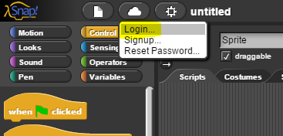
Next, when you’ve completed some work on a project, you’ll want to save it to the cloud. Click on the paper icon, then click Save As.
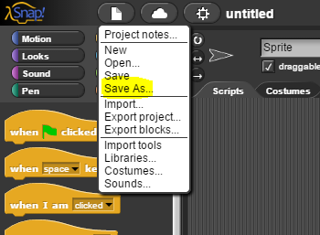
On the next screen, make sure Cloud is selected on the left side. Pick a good name for your project, then click Save.
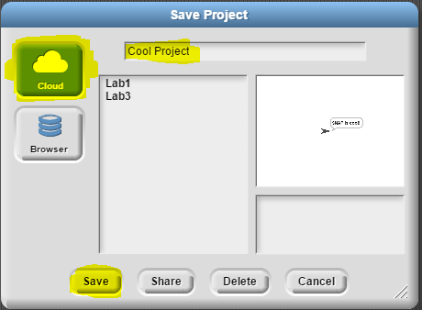
From now on, when you have this project open, you can quickly save by just selecting Save. When you want to share your project, go back to the Save As menu again, but instead of saving, select the project you want to share and select the Share button.
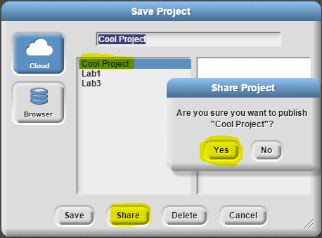
Once you click Yes, the URL that’s in your URL bar can be used as a link to share your project.
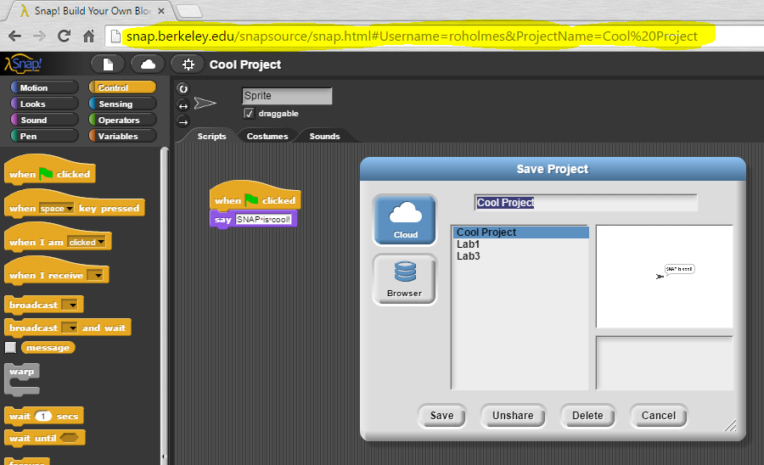
Use this entire link to submit your project on the grading site.

